Data Analytics Mini Project
JITHIN SHAJI
Phase 1
- Successfully Uploaded the excel file And changed the format of each column as you can see in the picture below:
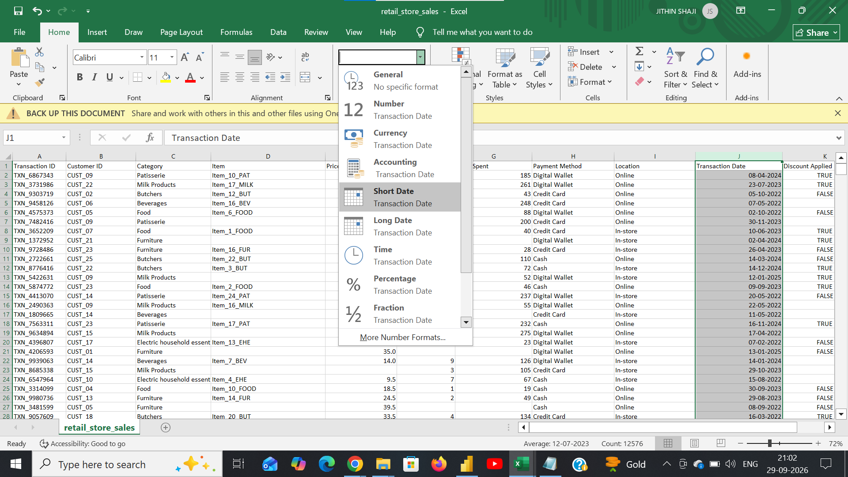
- Created Headings & Filters for the table
- 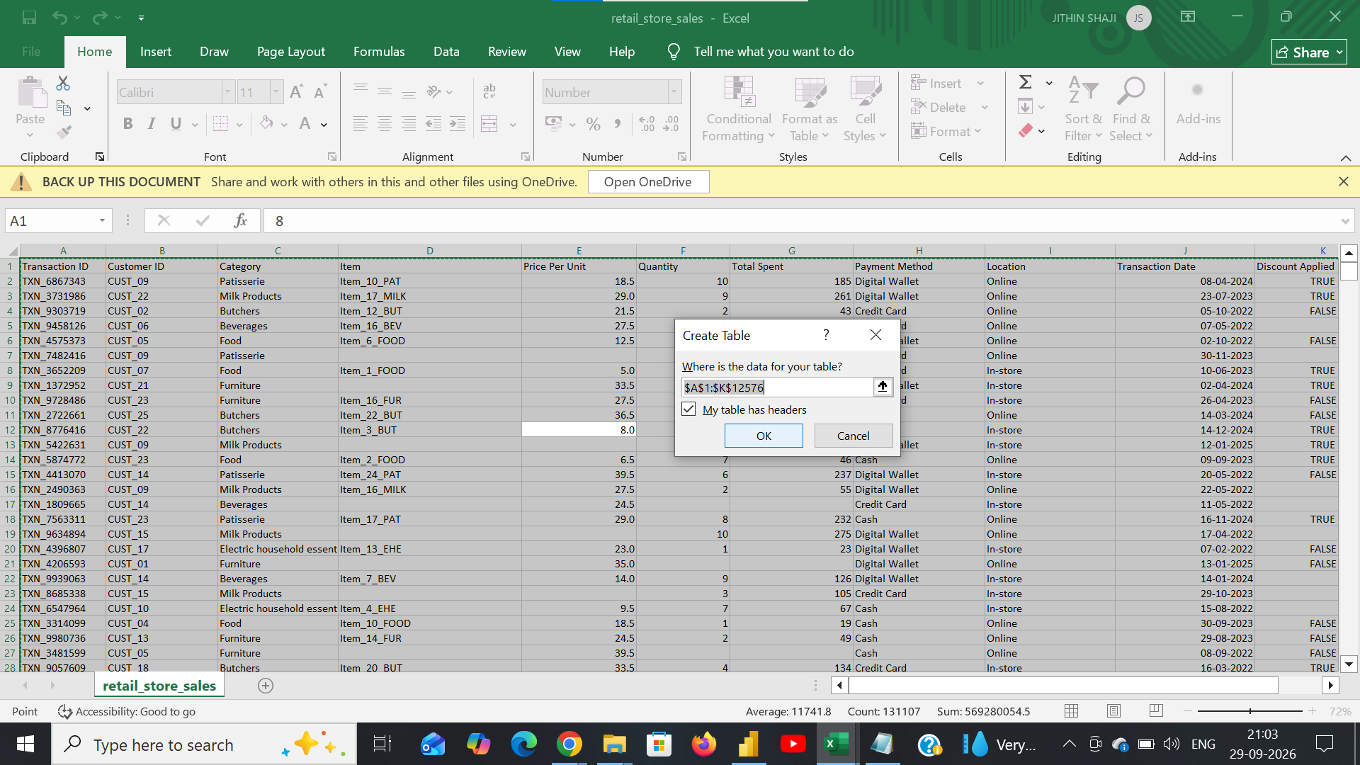
- Then Removed Duplicates 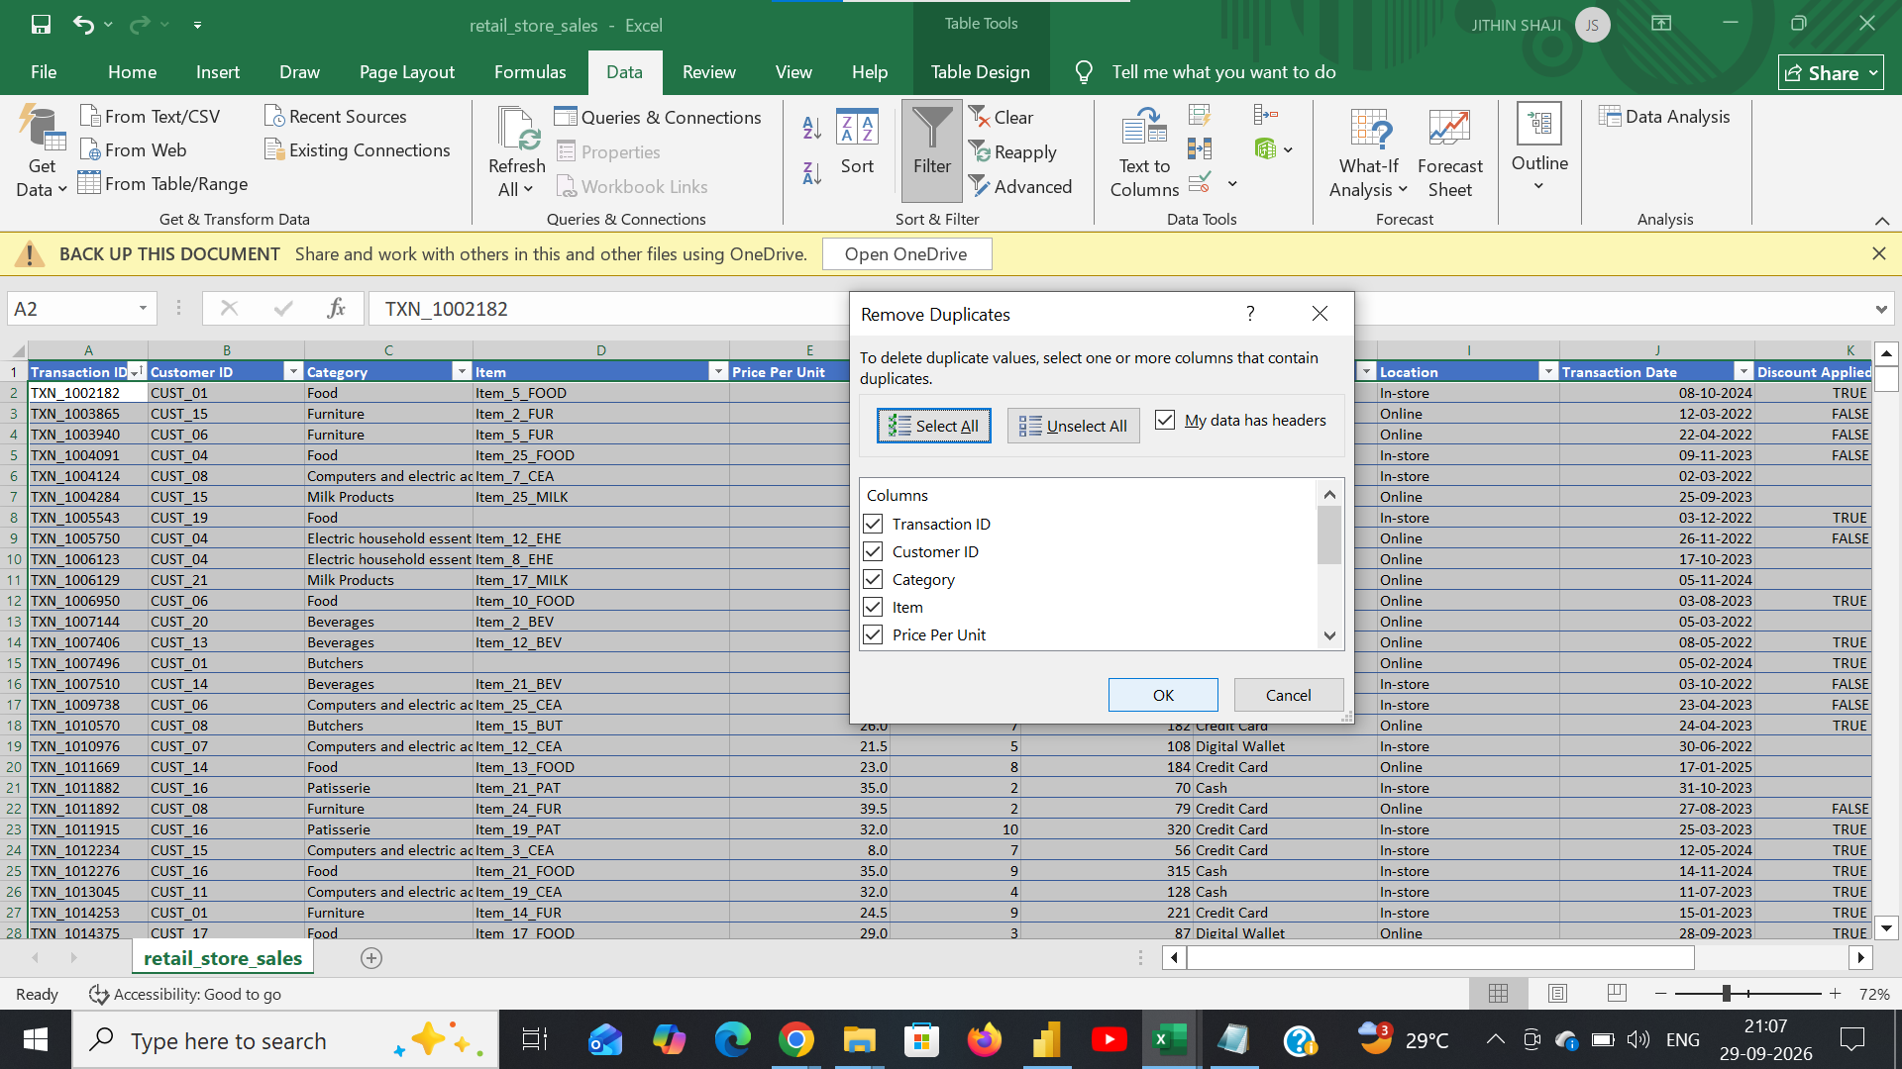
- Done Find & Replacement
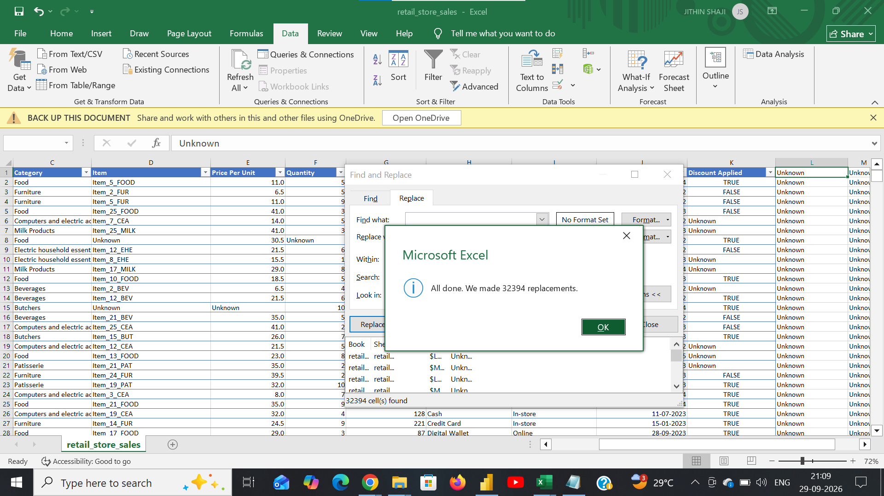
- Used ISBLANK Formula to Replace is there is any blank Columns
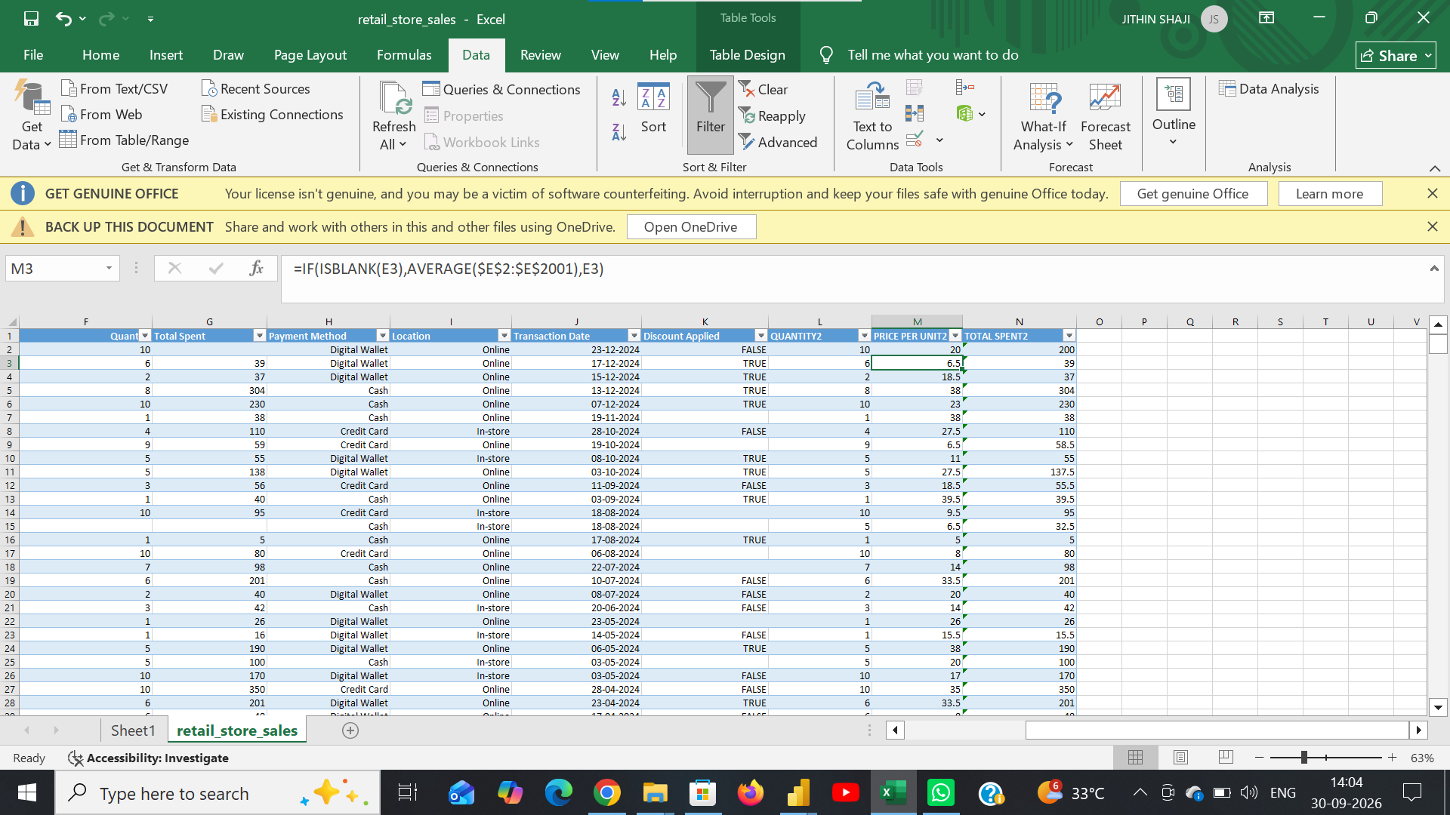

Phase 2
- After Cleaning the file through Excel Uploaded the file to Power BI
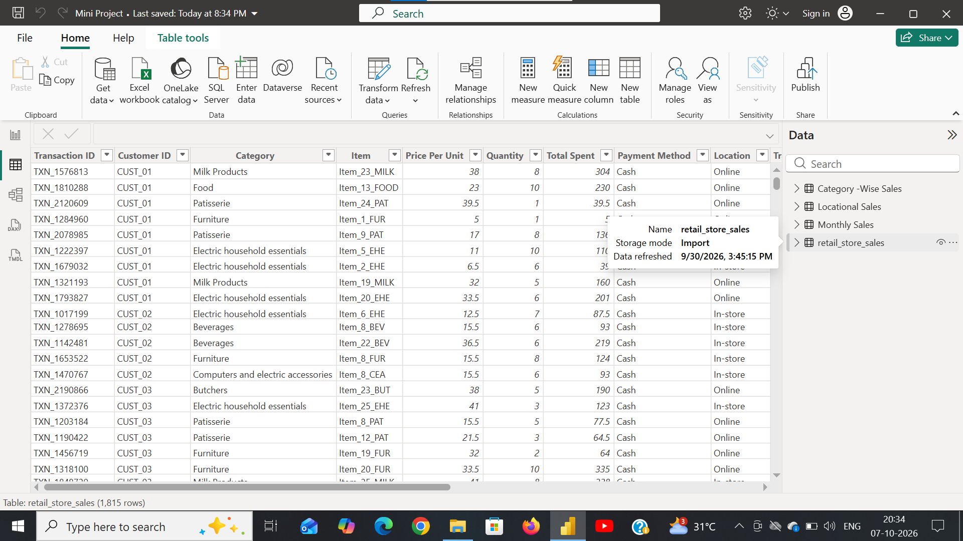
- After loading, the fields such as Transaction ID, Category, Quantity, Total Spent and Transaction Date became available in the Fields pane.
- 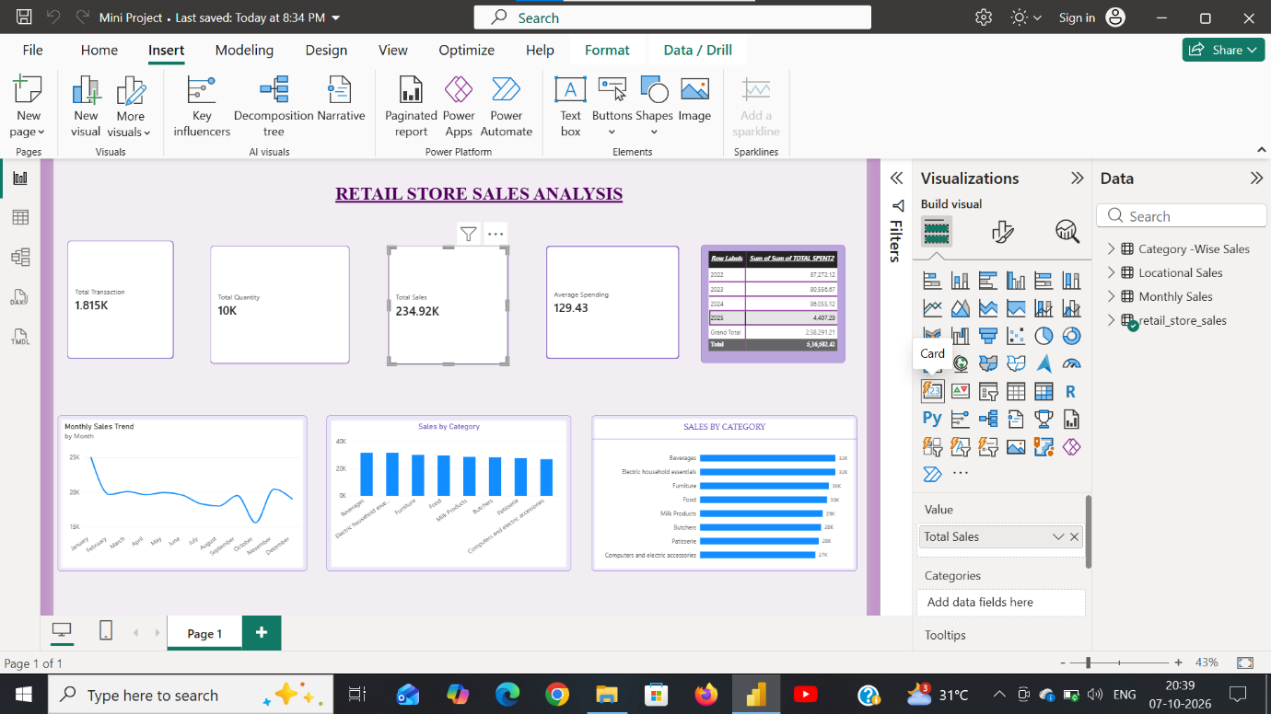Created cards
- Total Sales – Sum of Total Spent.
- Total Transactions – Count of Transaction ID.
- Total Quantity Sold – Sum of Quantity.
- Average Spending – Average of Total Spent
- A clustered column chart was used to compare sales between different product categories
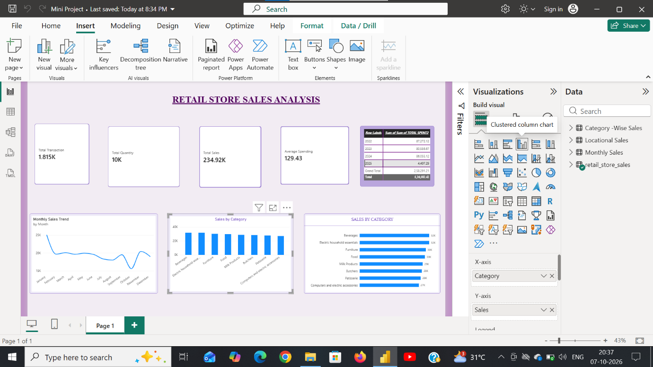

- A line chart was used to show how sales changed over time.
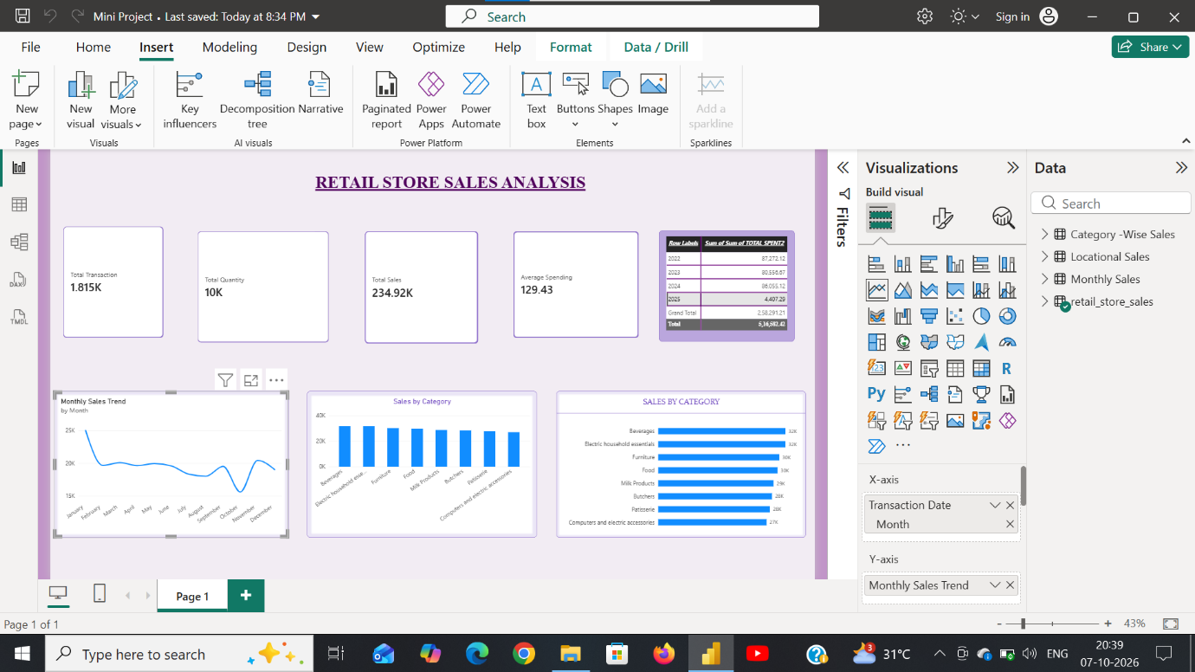

- A bar chart was used to compare sales between locations
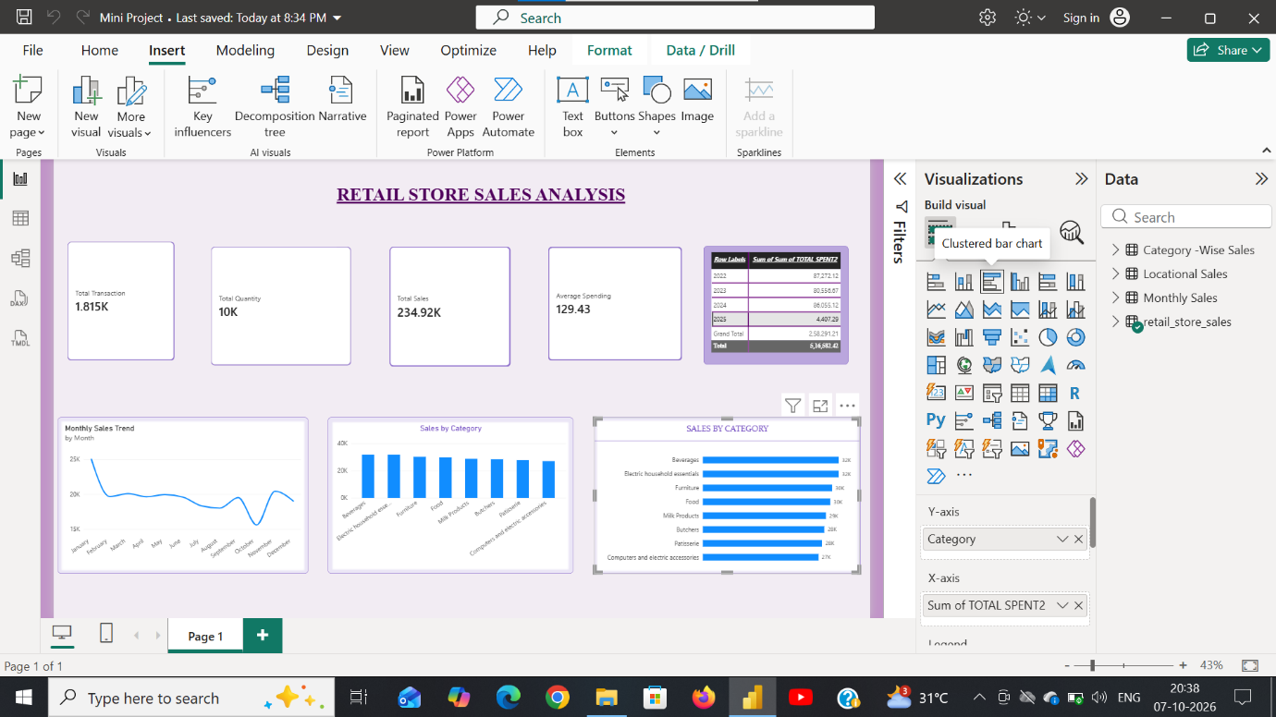

Completed the DASHBOARD
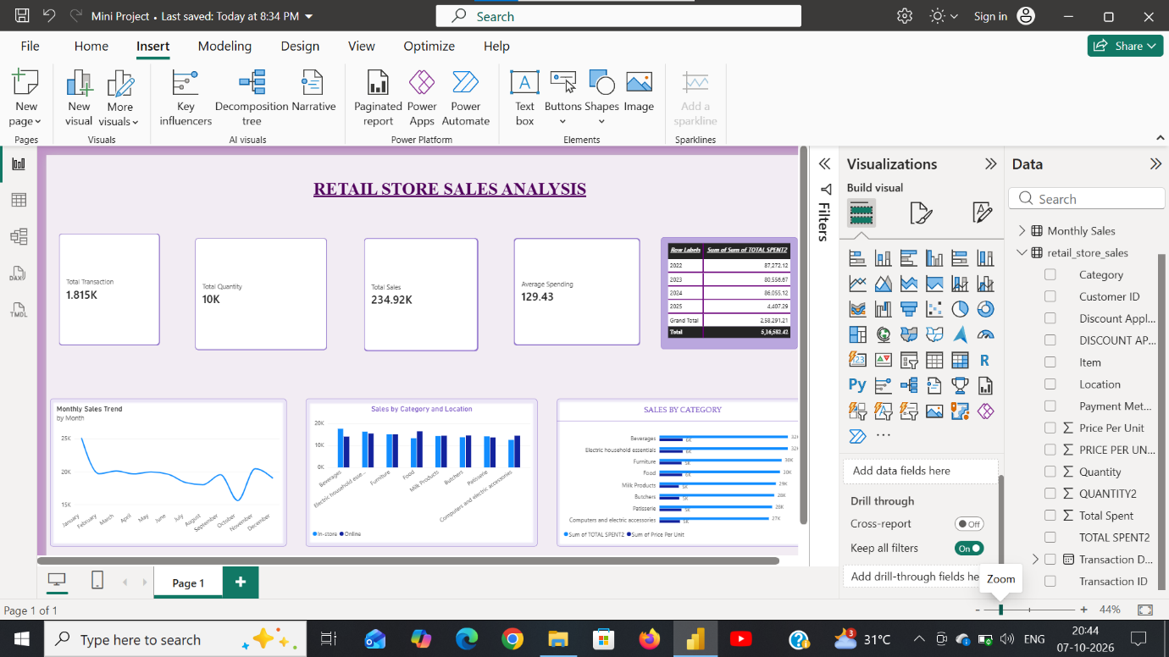

THANK YOU.

